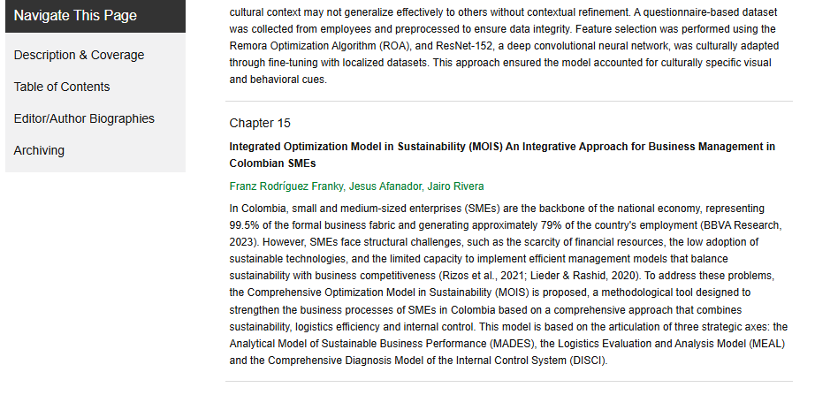
Link de publicación:
https://www.igi-global.com/book/building-applied-models-problem-solving/371424

