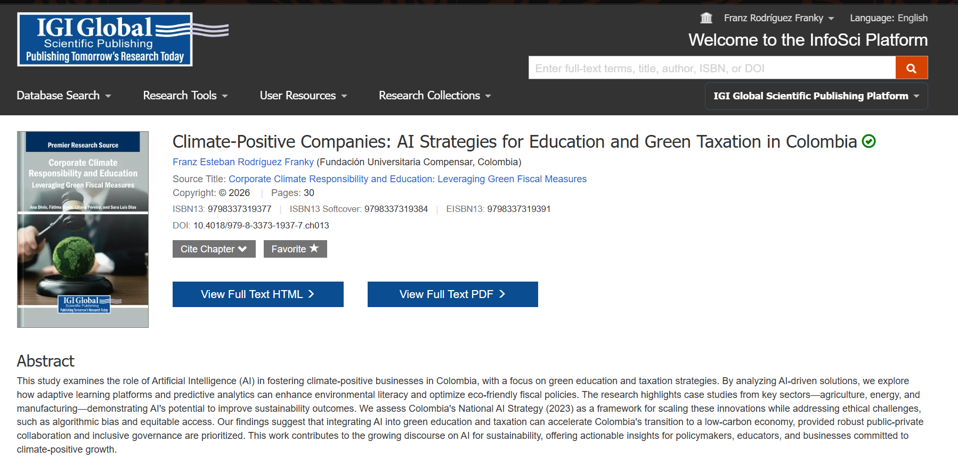
Link de publicación:
https://www.igi-global.com/book/corporate-climate-responsibility-education/367189

